Project Design Phase-II
Data Flow Diagram & User Stories

Date | 13 July 2026
Team ID | SWTID-2026-4732
Project Name | India's Agricultural Crop Production Analysis
Maximum Marks | 4 Marks

Data Flow Diagram:
The Data Flow Diagram represents the flow of agricultural data from the source dataset through preprocessing, cleaning, and Tableau visualization. The processed data is transformed into interactive dashboards and stories that provide meaningful insights. These insights help farmers, government analysts, and investors make informed decisions based on historical agricultural trends.
DIAGRAM:
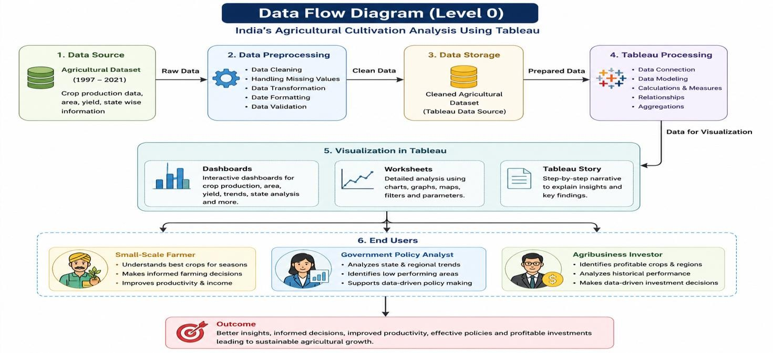
User Stories:
User Type | Functional  Requirement  (Epic) | User Story  Number | User Story / Task | Acceptance criteria | Priority | Release
Small-Scale Farmer | Dashboard Access | USN-1 | As a farmer, I want to access the Tableau dashboard to view agricultural production data. | Dashboard opens successfully and displays all visualizations. | High | Sprint-1
Small-Scale Farmer | Crop Analysis | USN-2 | As a farmer, I want to filter crop production data by state, season, and year. | Selected filters update the dashboard correctly. | High | Sprint-1
Small-Scale Farmer | Trend Analysis | USN-3 | As a farmer, I want to compare crop production trends over different years | Trend charts display accurate historical data. | Medium | Sprint-1
Government  Policy Analyst | Regional Analysis | USN-4 | As a policy analyst, I want to identify high and low-performing states. | Dashboard highlights regional production performance. | High | Sprint-1
Government  Policy Analyst | Seasonal Analysis | USN-5 | As a policy analyst, I want to analyze seasonal crop production trends. | Seasonal charts display correct information. | High | Sprint-1
Government  Policy Analyst | Report  Generation | USN-6 | As a policy analyst, I want to export dashboards for reporting purposes. | Dashboard can be exported successfully. | Medium | Sprint-2
Agribusiness Investor | Crop Comparison | USN-7 | As an investor, I want to compare crop production across different states. | Dashboard provides accurate comparison charts. | High | Sprint-1
Agribusiness Investor | Profitability Analysis | USN-8 | As an investor, I want to identify highperforming crops using historical data. | Dashboard displays production trends clearly. | High | Sprint-1
Agribusiness Investor | Interactive Dashboard | USN-9 | As an investor, I want to interact with charts and filters to explore agricultural insights. | All dashboard filters and charts respond correctly. | Medium | Sprint-2
All Users | Tableau Story | USN-10 | As a user, I want to view the Tableau Story to understand key agricultural insights | Tableau Story displays all insights in sequence. | Medium | Sprint-2

